Team assignment WBS and descriptions
The overview – high level with wide picture ..
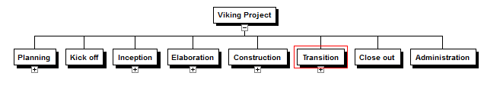
.. and more detail ..
- Planning – Describes how to planning project with estimation about resource and duration.
Planning task is a task that is repeated regularly.
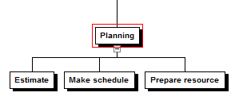
Include estimate, define project’s goals and objects, preapare schedule, prepare resource for project.
- Kick off - Project officially runs.
- Review Project Stages/Methodology.
- Define the Project Team
- Discuss Risk, Issue and Change Management
- Review High-Level Project Plan.
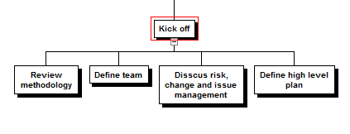
- Inception – define requirements, present system in high level view for customer.
Plan can be modified when customer change requirements in this task.
Make URD.
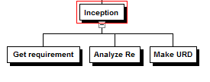
- Elaboration – high level design and architect, analysis and design basic functionality.
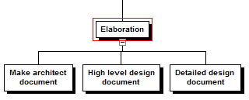
- Construction – coding and testing.
Unit testing, integration testing, and others.
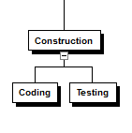
- Transition - collect feedback and determine customer satisfaction by using acceptance test.
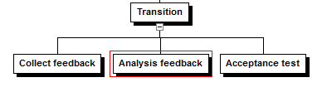

- Close out – release and install. I think need to make user manual.
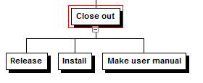
- Administration – maintenance and support after selling.

